CASA’s for CASA
Playhouse Raffle 2018 Sponsor Form
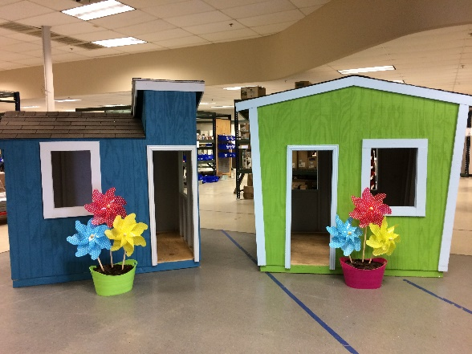
Raffle Drawing Date – August 4, 2018
PLEASE PRINT
Sponsor/Business Name
Contact Name (if a business)
Address
 | City |  |  | State |  | Zip
Business Phone |  |  |  | Cell
Email
Sponsor Level
Notes
 |  | Sponsor Signature |  |  |  |  | Date
Please forward Business Logo to connie@casagalveston.org for signage and website recognition (if applicable)
CASA Office Address: 2000 Texas Ave, Suite 641, Texas City, TX 77590

